|  |
| --- |
| detail of persons hands with scissors, markers, workingHotel Booking Analysis REPORT |

|  |  |  |
| --- | --- | --- |
| Analysis Report- By Mayank Gupta |  |  |
| Email: mayankgup.731@gmail.com | Tel: +91 9315809514 |  |

# Hotel booking

BUSINESS PROBLEM:

The hotel industry faces a significant challenge with high cancellation rates, impacting revenue and operational planning. This report aims to analyze hotel booking data to understand the factors contributing to high cancellation rates and propose strategies to reduce cancellations and increase revenue for both city hotels and resort hotels.

|  |
| --- |
|  |

ASSUMPTIONS:

1. The data provided is accurate and represents a typical sample of hotel bookings.
2. No unusual occurrence of data within the dataset that impact analysis process.
3. The information is still current and can be used to analyse hotel’s plan in efficient manner.
4. There is no unanticipated negative to the hotel, employing an advised technique.
5. The hotels are not using any of the suggested solutions.
6. The biggest factor affecting the effectiveness of revenue is booking cancellation.
7. Client makes hotel reservation in the same year they make cancellation.

RESEARCH QUESTIONS:

1. What are the variables that affect hotel reservation cancellation?
2. What is the overall cancellation rate for city hotels and resort hotels?
3. How does the cancellation rate vary by month?
4. Which countries have the highest cancellation rates?
5. How do average daily rates (ADR) compare between city hotels and resort hotels over time?
6. How can we make hotel reservation cancellation better?
7. How will hotels be assisted in making pricing and promotion better?

HYPOTHESIS:

1. More cancellation occurs due to high price and seasonality.
2. Cancellation rate between City hotel and Resort Hotel are probably same.
3. The cancellation rate is higher during specific months due to seasonal factors.
4. Certain countries and market segments have higher cancellation rates.
5. Resort hotels may have a higher ADR than city hotels due to location and amenities offered.
6. When there is longer waiting list, customer tends to cancel their booking.
7. The majority of clients are coming from offline travel agent to meet their reservation.

# Analysis and findings

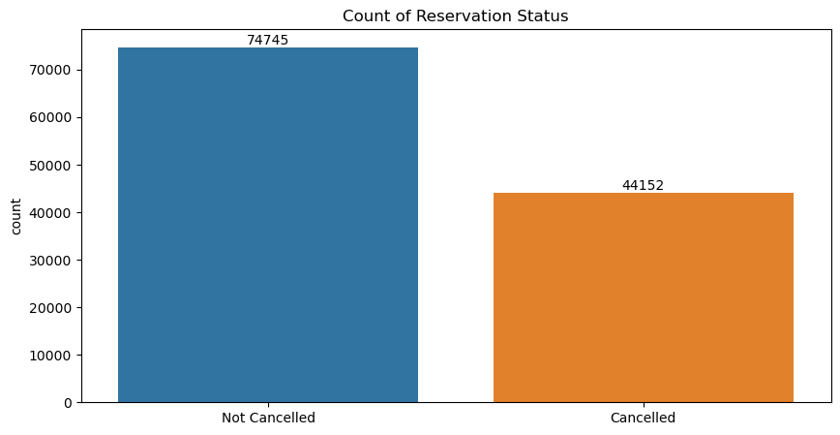

**Findings**

* **Approx. 62% of reservation is not cancelled, and**
* **The overall cancellation rate is 37.13%, indicating that more than one-third of the bookings are cancelled. This is a significant portion and highlights the need for strategies to reduce cancellations.**

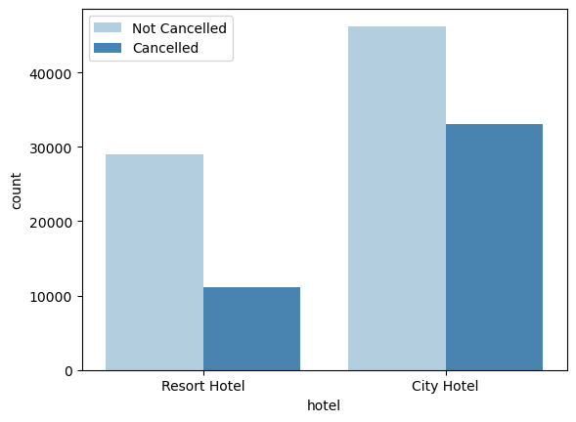

**Findings**

* **The cancellation rate in Resort hotel is around 28%, and the cancellation rate in City hotel is more than 41%.**
* **The cancellation rate in the City Hotel is very High, indicating that in every 10 customers in city hotels 4 to 5 customers are churning and making their reservation cancel.**
* **This is happing because of waiting list is very high and the price is irrelevant with respect to their services.**

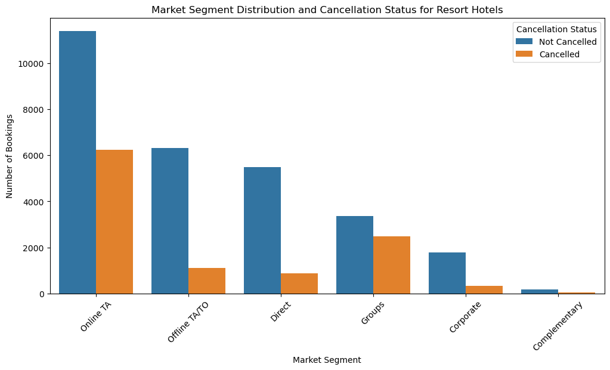

**Findings**

***The overall cancellation rate in resort hotels is 27.9%.***

* **Online Travel Agents (OTA): The majority of bookings come from OTAs, and around *35%* of these are cancelled. This aligns with previous findings where OTAs had high cancellation rates.**
* **Offline Travel Agents/ Tour Operators (TA/TO): This segment also has a substantial number of bookings with a moderate cancellation rate.**
* **Groups: Group bookings form a significant portion, with a notable number of cancellations *(i.e., approx. 42%),* indicating a need for focused strategies in this segment.**
* **Direct Bookings: While fewer in number compared to OTA and TA/TO, direct bookings show a lower cancellation rate, suggesting the reliability of this segment.**
* **Corporate: This segment has a lower number of bookings with relatively fewer cancellations, making it a stable source of revenue.**

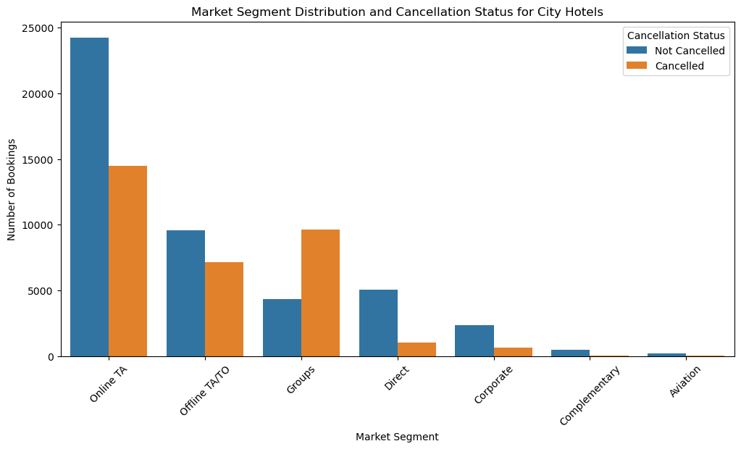

**Findings**

* **Online Travel Agents (OTA) contribute 62.44% to total City hotel bookings and 37.97% to cancellations.**
* **Groups account for 17.45% of total City Hotels bookings but with the very high cancellation rate of 69%. This might be happen because the information about the hotel provided by the Groups to the clients is not accurate.**

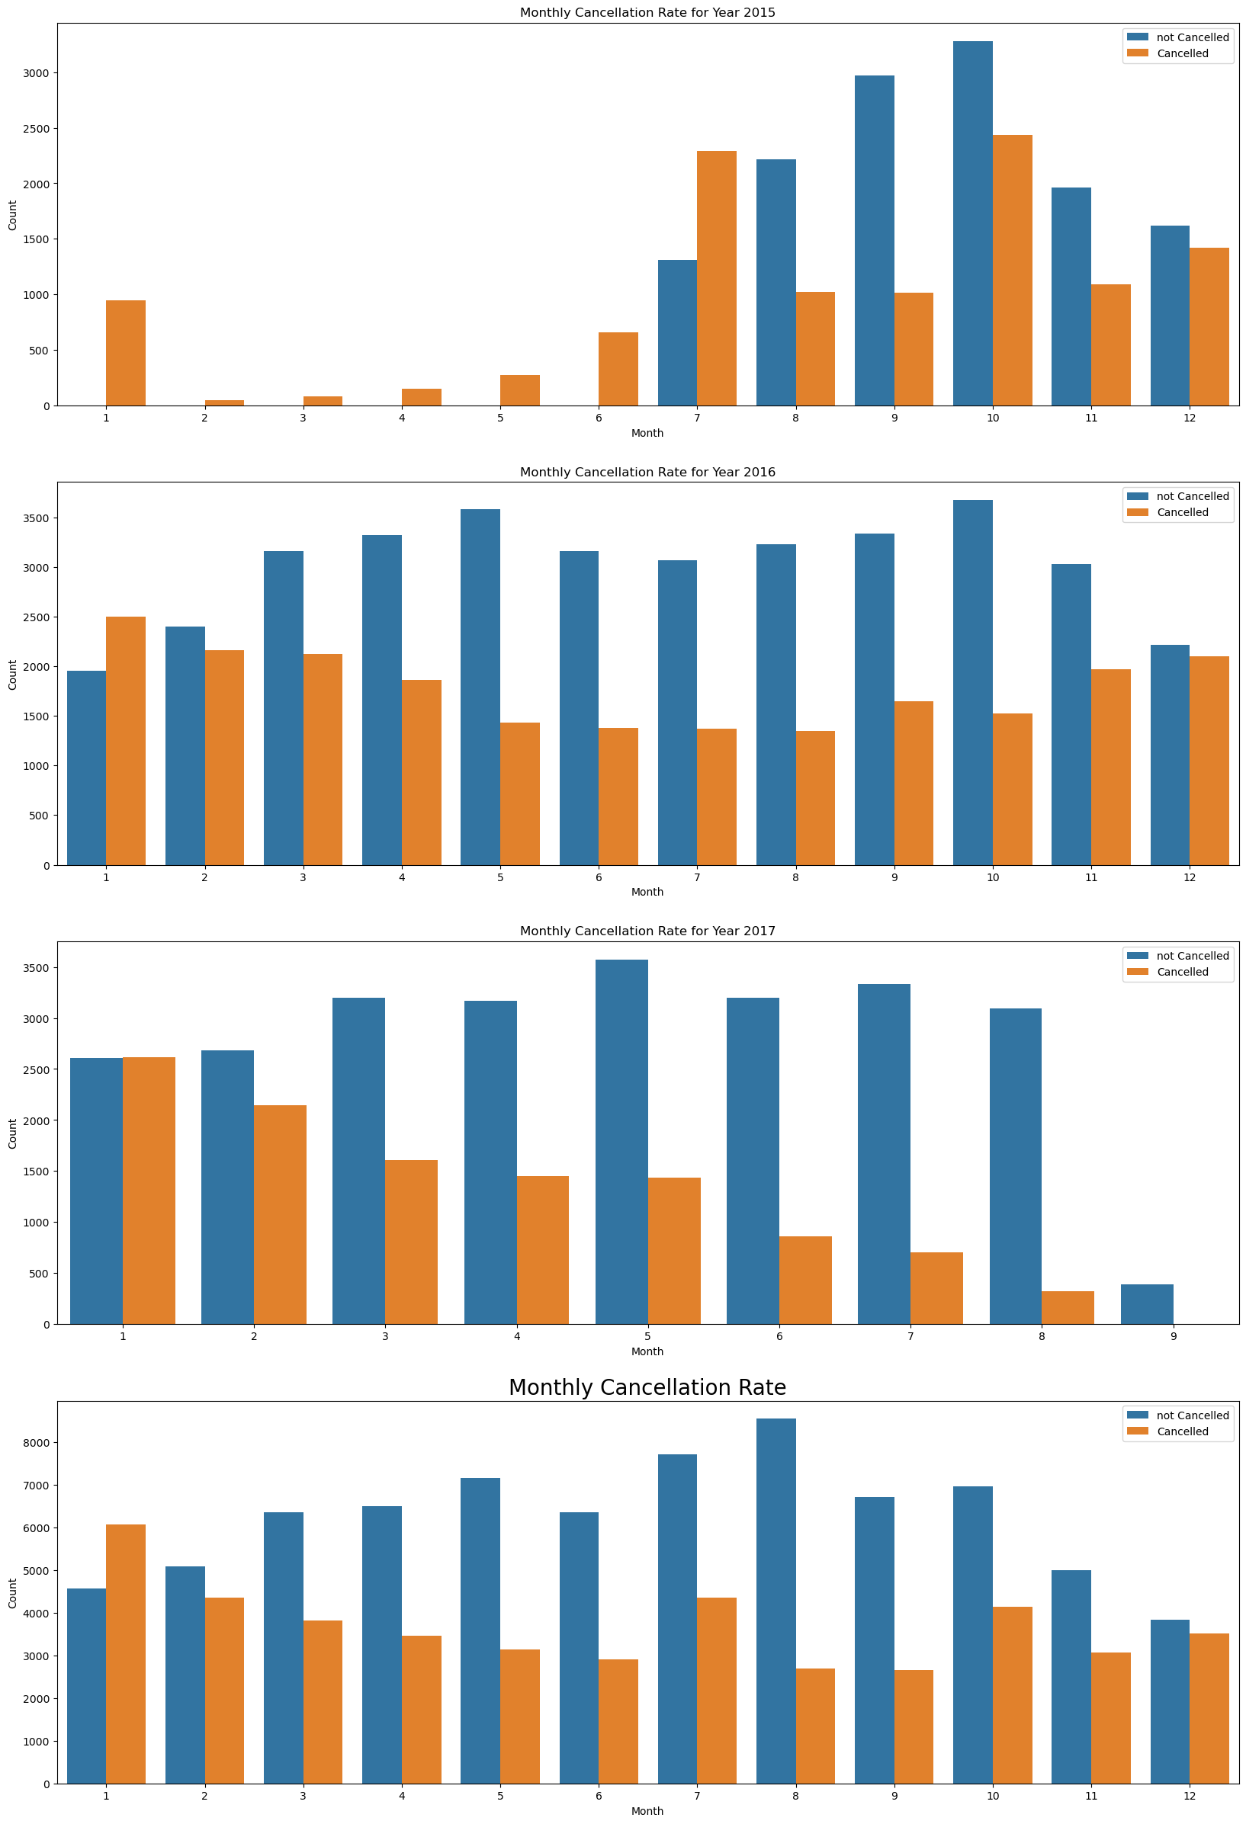

**Findings**

* **High Cancellation Months: Contrary to the previous assumption, August shows a lower cancellation rate compared to some other months.**
* **Higher Cancellation Rates: The months of January, February, July, and December appear to have higher cancellation rates, while August has a relatively lower rate.**

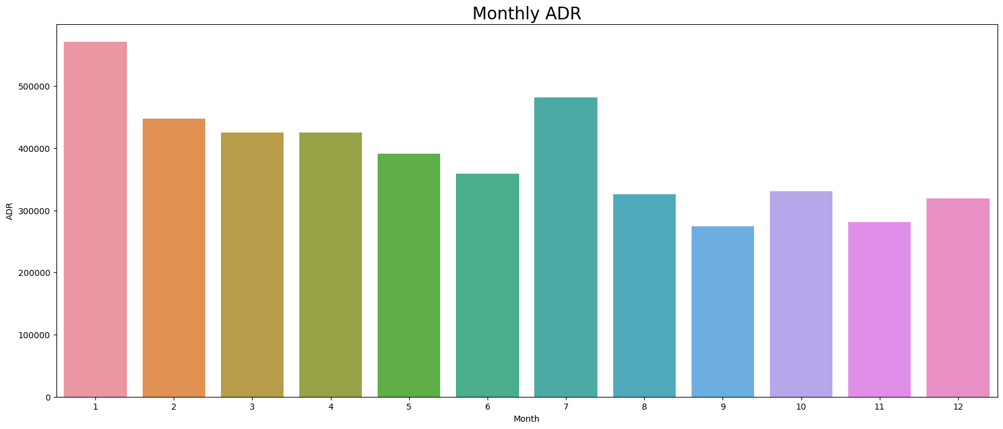

**Findings**

* **August month shows a lower cancellation rate compared to some other months because of less Price / ADR**
* **The main reason behind the higher cancellation in the months of January, February, July, and December appears to be the higher prices.**

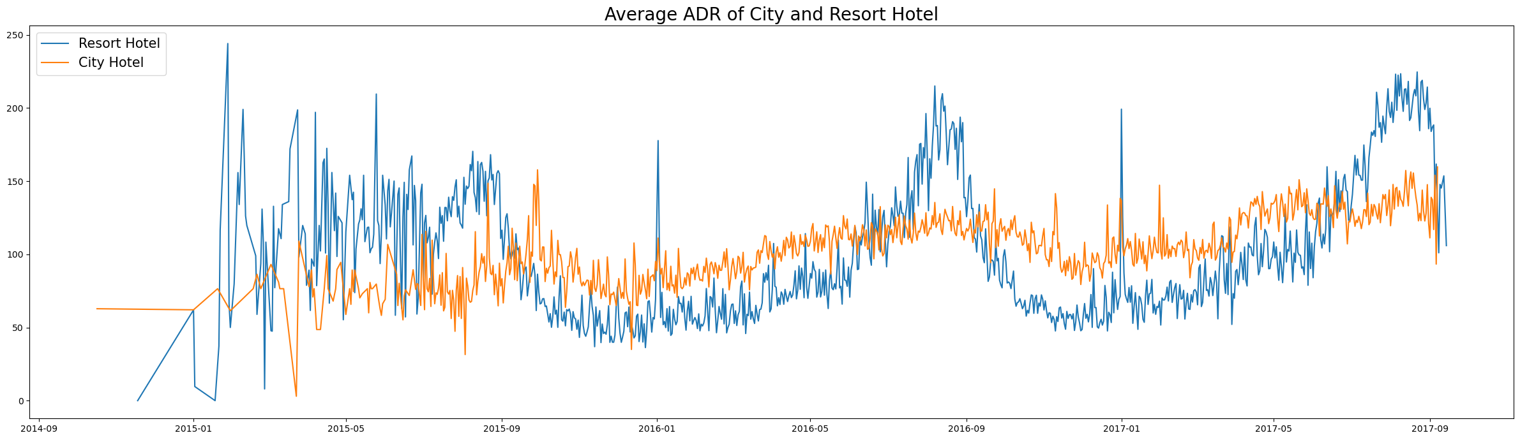

**Findings**

* **The ADR (Average Daily Rate) for resort hotels is generally higher and more volatile compared to city hotels. This could be due to the seasonal nature of resort bookings, higher amenities, and different target markets.**

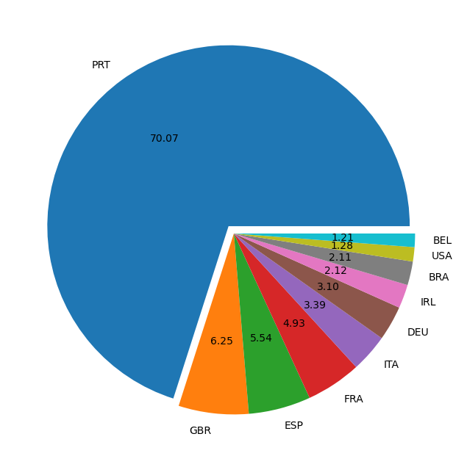

**Portugal (PRT) has the highest cancellation rate at 70.07%, followed by the United Kingdom (GBR) at 6.25% and Spain (ESP) at 5.54%. This suggests that certain countries are more prone to cancellations, which could be due to prices, economic factors, travel regulations, or cultural tendencies.**

# Summary of Findings

* **Overall Cancellation Rate:** The cancellation rate remains significant at 37.13%, requiring targeted interventions.
* **Monthly Trends:** The revised analysis shows that cancellations peak in January, July, and October, while August has a comparatively lower cancellation rate.
* **Country-Specific Trends:** Portugal (PRT), the United Kingdom (GBR), and Spain (ESP) have the highest cancellation rates, similar to the previous findings.
* **Market Segment Insights:** Online Travel Agents and Groups continue to be the most problematic segments in terms of cancellations.
* **Revenue Insights:** Resort hotels generally have higher ADR compared to city hotels, indicating opportunities for revenue optimization during peak seasons.

# Recommendations

1. **Revise Cancellation Policies**: Implement stricter policies during months with high cancellation rates (January, July, and October) to mitigate revenue loss.
2. **Focus on Country Trends:** Conduct targeted marketing and customer feedback campaigns in countries with high cancellation rates to understand and address underlying causes.
3. **Enhance Customer Experience:** Improve services and communication for market segments with high cancellations, particularly OTAs and Groups.
4. **Dynamic Pricing:** Adjust pricing strategies for resort hotels during off-peak seasons to optimize occupancy and revenue.

**By implementing these strategies, hotels can effectively address high cancellation rates and enhance overall revenue management.**